NETWORKING 1
What is a Network?
Network is a collection of interconnected computing devices that share data, resources, and services.
What is Networking?
Networking is the physical and logical act of connecting those devices, designing the architecture, and managing the communication rules.

Types of Networks:

PAN (Personal Area Network):
Range: Within 10 meters (around a single person).
Usage:Interconnecting personal devices like smartphones, wireless headphones, smartwatches, and laptops.
Core Technology: Centred around wireless standards like Bluetooth.
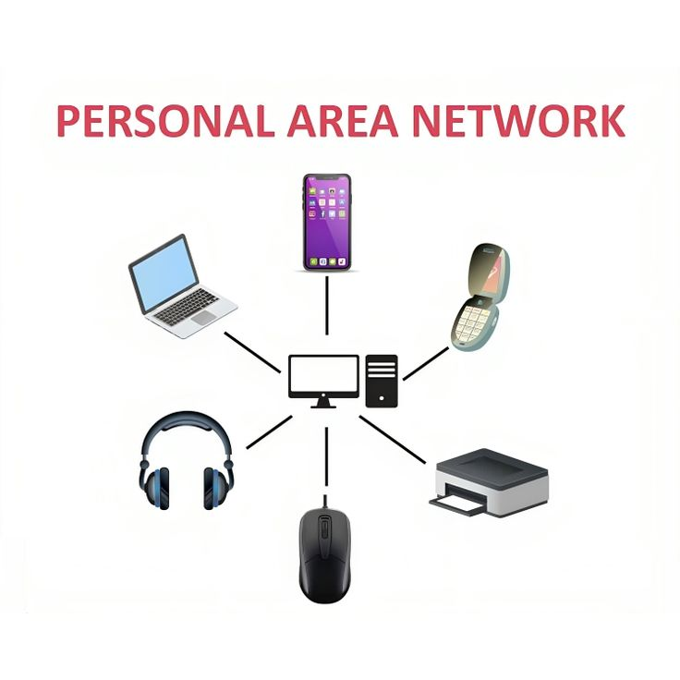
LAN (Local Area Network):
Range: Limited to a single building, office, home, or school.
Usage: Sharing local resources like printers, files, and internet access among a group of users.
Core Technology: High-speed data transfer using Ethernet cables or Wi-Fi (WLAN). Highly secure with low data transfer delays.
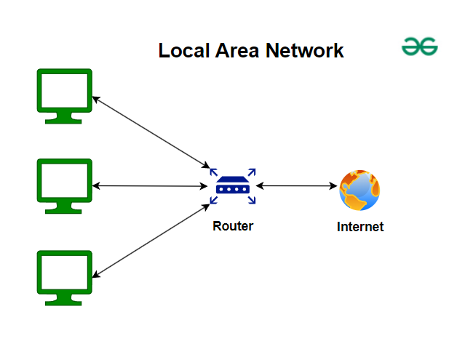
CAN (Campus Area Network):
Range: Spans a cluster of nearby buildings (e.g., a university campus or corporate park).
Usage: Larger than a LAN but smaller than a MAN; it links multiple departmental LANs together.
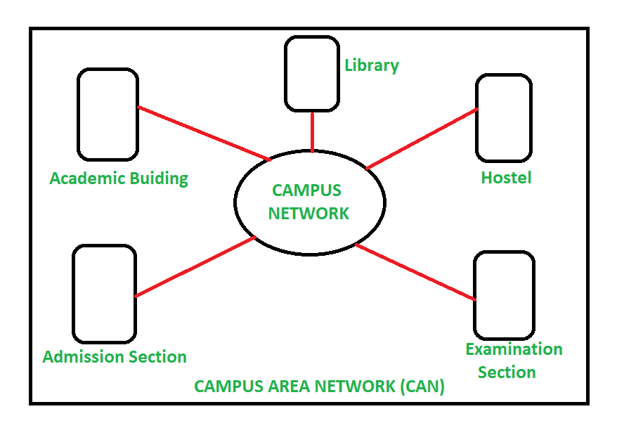

MAN (Metropolitan Area Network):
Range: Covers an entire city or town (typically 5 to 50 km).
Usage: Often owned by a consortium of users or a single provider (like a cable TV network or city-wide free Wi-Fi).
Core Technology: Uses high-speed fiber-optic cables to bridge multiple LANs across the metropolitan zone.
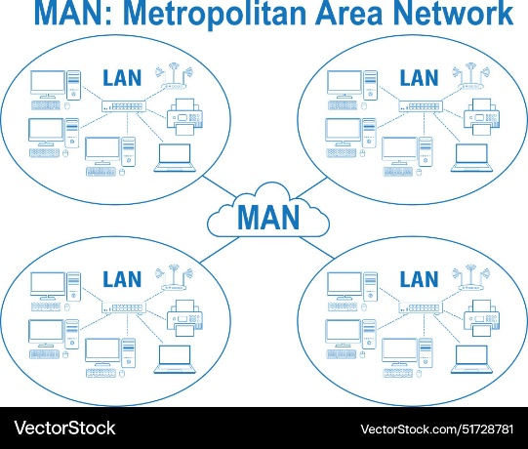
WAN (Wide Area Network):
Range: Extends across countries, continents, or the globe.
Usage: Connects business branches globally. The most famous example of a public WAN is the Internet.
Core Technology: Relies on public carriers, telephone lines, satellite links, and leased lines. Speed is generally lower than a LAN due to distance.
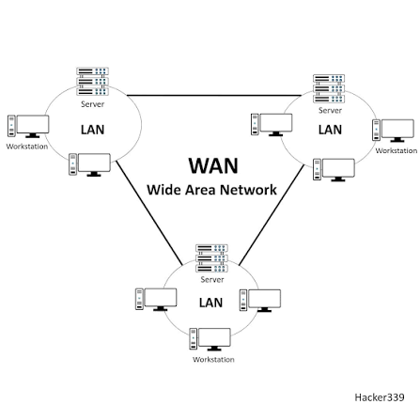
Topology
Topology determines how data flows from one point to another inside a network.
Types of Topologies
1. Bus Topology
Structure: All devices connect to a single central cable called the backbone or bus, with terminators at both ends.
How it works: Data broadcasts along the shared cable, and each node checks if the packet is meant for it.
Advantages: Inexpensive, uses minimal cable, and is easy to set up for small, legacy local area networks (LANs).
Disadvantages: A break in the main backbone disables the entire network; heavy traffic causes collisions and drops performance.
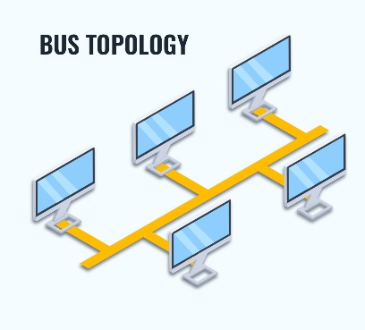
2. Peer-to-Peer (P2P) Topology
Structure: A dedicated, direct link connecting two specific devices exclusively.
How it works: Communication flows back and forth only between those two endpoints without sharing the medium.
Advantages: Maximum speed, high security, and zero media contention.
Disadvantages: Limited scalability; not practical for connecting large groups of devices.
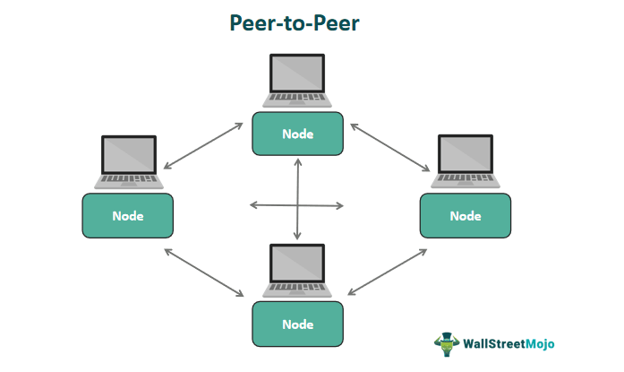
3. Star Topology
Structure: All nodes connect individually to a central hub, switch, or router.
How it works: Data passes through the central device, which routes packets directly to the target node (when using a switch) or broadcasts them (when using a hub).
Advantages: Easy to add or remove devices; failure of one node or cable does not affect the rest of the network.
Disadvantages: If the central switch/hub fails, the entire network goes down; requires more cable than a bus topology.
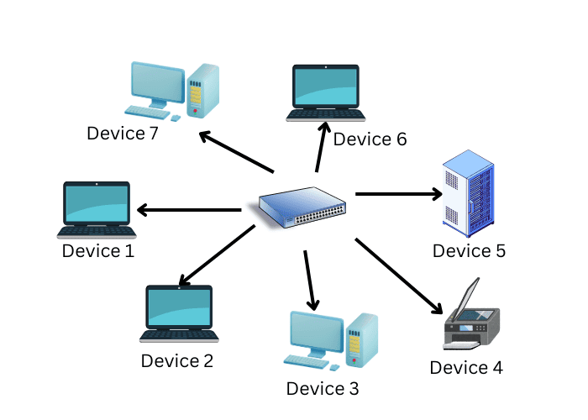
4. Ring Topology
Structure: Devices form a closed circular loop, where each node connects to exactly two neighbors.
How it works: Data travels unidirectionally (or bidirectionally in dual-ring setups) from node to node, often using a token-passing method.
Advantages: Orderly data flow with predictable performance and low collision rates.
Disadvantages: A break in a single cable or node can disable the entire loop (unless a dual-ring backup exists), and scaling requires temporarily breaking the ring.
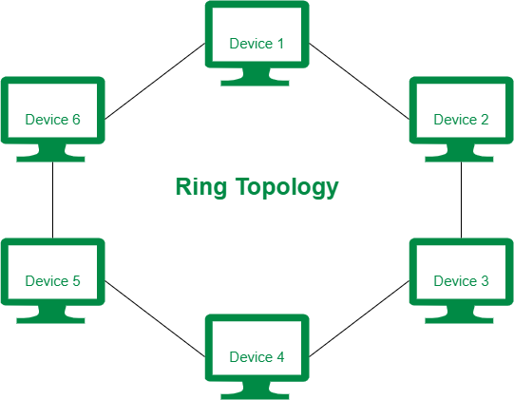

5. Mesh Topology
Structure: Nodes interconnect with multiple redundant paths. Divided into full mesh (every node connects to every other node) and partial mesh (only key nodes have multiple connections).
How it works: Data dynamically routes through alternative paths if a link fails.
Advantages: Extremely high reliability, fault tolerance, and security; ideal for mission-critical operations.
Disadvantages: Complex to install, configure, and maintain; very high cost due to heavy cabling and port requirements.
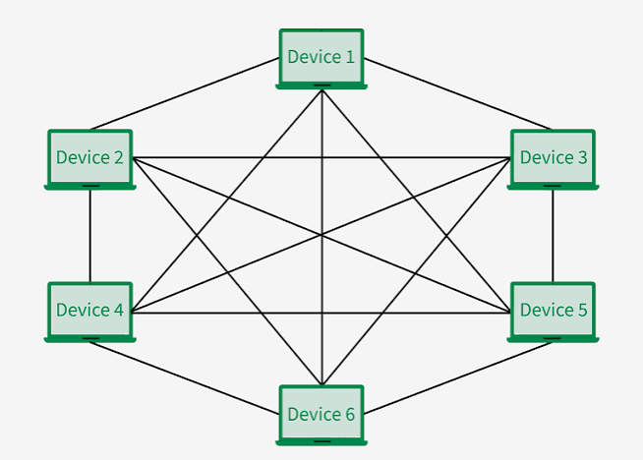
6. Tree (Hierarchical) Topology
Structure: Combines star and bus topologies into a hierarchical tree or branch structure.
How it works: Groups of star-configured workstations connect to a central bus backbone or root node.
Advantages: Highly scalable; easy to isolate faults and manage large corporate or campus networks.
Disadvantages: Heavily dependent on the main trunk/backbone cable; if the main trunk fails, major segments go down.
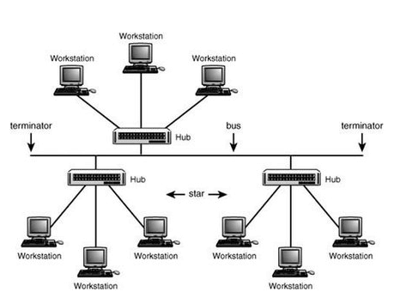
7. Hybrid Topology
Structure: A combination of two or more distinct basic topologies (such as a star-ring or star-bus network).
How it works: Integrates different subnet layouts to match the specific structural needs of an organization.
Advantages: Extremely flexible, scalable, and tailored to custom enterprise environments.
Disadvantages: Design, configuration, and troubleshooting are complex; requires higher management overhead.
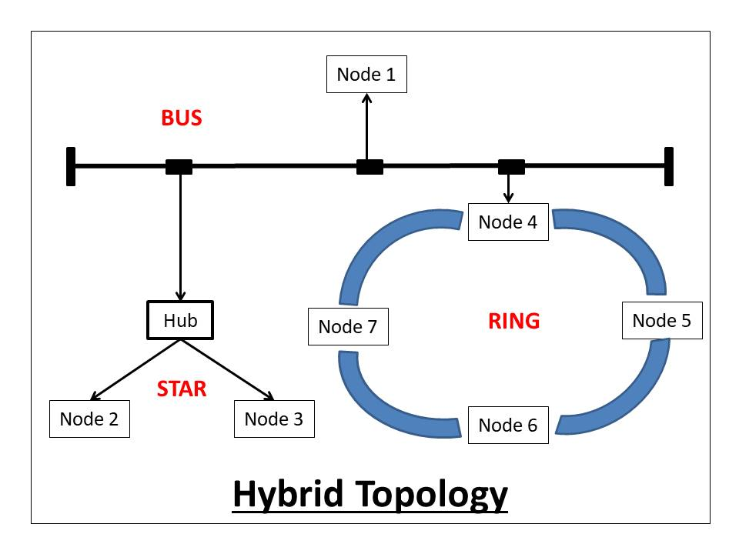

Submarine Cable map
Submarine cable maps tracks the active and planned underwater fiber-optic networks that handle the vast majority of global internet traffic.
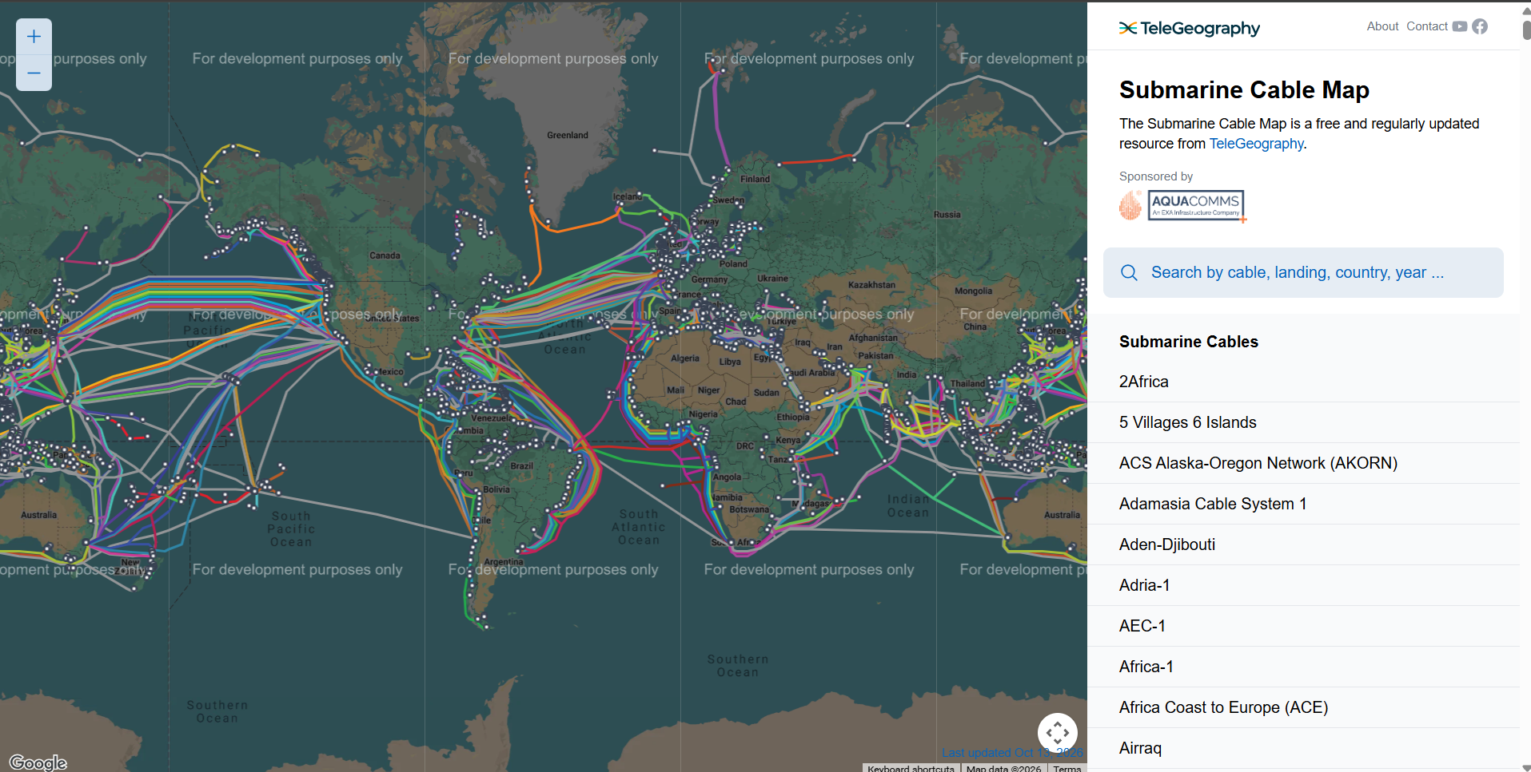

Project Waterworth:
Project Waterworth is a multi-billion-dollar subsea fiber-optic cable initiative launched by Meta. Spanning over 50,000 kms, it is designed to become the world's longest subsea cable network once operational. Expected operational by 2030.
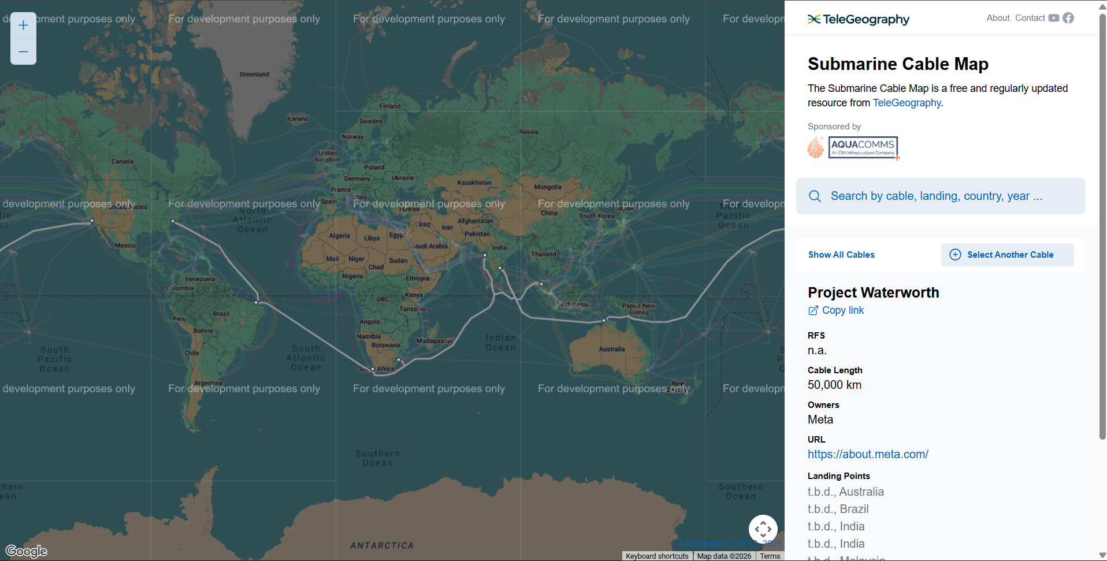

Wireless Networks
Ad-Hoc Network (Peer-to-Peer)
Devices connect directly to one another on a temporary, as-needed basis without any permanent infrastructure.
How it works: If Device A wants to talk to Device B, they establish a direct, 1-to-1 link.
Key Characteristic: Highly temporary and spontaneous.
Common Example: Using Bluetooth to pair a phone to a speaker, or using Wi-Fi Direct / AirDrop to send a file between two laptops.
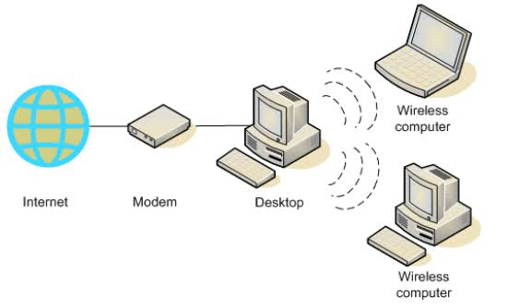
Mesh Network (Many-to-Many)
Devices (called nodes) connect interdependently to multiple other devices, creating a decentralized web of connectivity.
How it works: Data "hops" from node to node across the best available path to reach its destination. If one node drops out, the network automatically calculates a new route.
Key Characteristic: Extremely reliable, extensive coverage, and "self-healing."
Common Example: Modern Whole-Home Mesh Wi-Fi systems (like Eero or Google Nest Wi-Fi) and smart home setups where light bulbs route signals to one another.
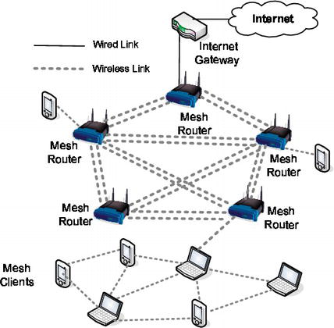
Star Network (Centralised)
Every individual device connects directly to a single central hub, which manages all data traffic.
How it works: Devices cannot talk directly to each other; all communication must go through the central router or switch first.
Key Characteristic: If the central node breaks, the entire network fails (Single Point of Failure).
Common Example: A traditional home Wi-Fi network, where your phone, laptop, and smart TV all connect independently back to a single internet router.
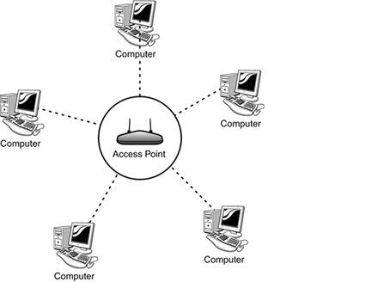
Infrastructure wireless network
Infrastructure wireless network is a setup where wireless devices (such as laptops, phones, and sensors) connect through a central hardware point—like a Wireless Access Point (AP) or base station—rather than communicating directly with each other.
Key Components
Access Point (AP): Acts as the bridge between wireless client devices and the wired network backbone (Ethernet switches, routers, and the internet).
Wireless Controller (WLC): Used in larger enterprise networks to manage multiple lightweight APs, handle roaming, and enforce security policies centrally.
Distribution System: The wired network infrastructure (usually Ethernet or fiber) that links access points to servers, local area networks (LANs), and wide area networks (WANs).
Common Applications
Enterprise & Campus Wi-Fi: Office buildings, universities, and hospitals using dense AP grids.
Public Hotspots: Airports, hotels, and cafes offering managed internet access.
Cellular Networks (5G/LTE): Base stations and centralized radio access networks (C-RAN) handling wide-area mobile traffic.
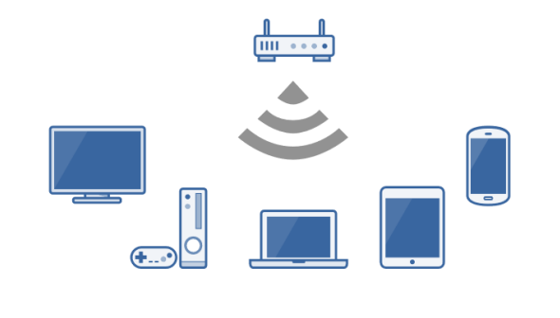
Network Architectures
In a client-server architecture, centralized servers store data and process requests from dependent clients, whereas in a peer-to-peer (P2P) architecture, equal participant nodes (peers) act as both clients and servers to share resources directly.
Client-Server Architecture
Core Structure: Centralized design featuring dedicated, high-capacity servers and lightweight client devices (such as web browsers or mobile apps).
Data Storage: Centralized on the server side, ensuring unified control and simpler backups.
Scalability: Limited by server capacity; handling massive traffic requires vertical scaling or multi-server data centers.
Reliability & Risk: Prone to a single point of failure—if the main server crashes or is compromised, the entire network or service goes down.
Security: Easier to administer, patch, and monitor from a central authority.
Common Examples: Web applications, cloud storage, enterprise databases, and email systems.
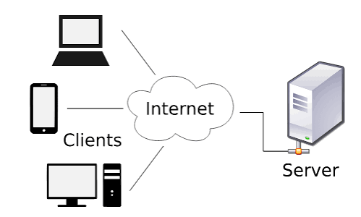
Peer-to-Peer (P2P) Architecture
Core Structure: Decentralized model where every node (peer) has equal status and can both request and provide services.
Data Storage: Distributed across the participating peers rather than held in one central database.
Scalability: Naturally self-scalable; as more peers join the network, total bandwidth, storage, and processing capacity increase.
Reliability & Risk: High fault tolerance and no single point of failure—if one peer disconnects, the rest of the network continues to function.
Security: Harder to control uniformly because security management is decentralized across independent nodes.
Common Examples: File-sharing networks like BitTorrent, blockchain cryptocurrencies (Bitcoin), and decentralized collaboration tools.


